Project Journal – XML

Eoin Fitzsimons

# Progress Tracker

## Week 1

I made the XML and the Schema, or at least started on them. It was just very basic elements that were strings and integers with no constraints.

## Week 3

I made a fancy schema to restrict the elements according to what was requested of me. I found that my main issue of the xsd not validating the xml was because I was not using a namespace in my xml, by changing xsi: SchemaLocation to xsi:noNamespaceSchemaLocation I fixed this issue. Then I needed to restrict the code to a pattern of three numbers, then a hyphen, then two numbers, I achieved this by using <xs:pattern value="\d{3}-\d{2}"/> \d{n} denotes the case where you must use n amount of numerical characters, in this case it is three then two, the ‘-‘ denotes the hyphen separating the two number groups.

## Week 8

I added the search feature to the website, I discovered how to do this through W3Schools. I tried for a long time to do this through an external script but was completely stumped as to what I did wrong, when I simply moved the code into my main html file through the xslt everything functioned properly, and I was relieved. I thought it may have been due to an external stylesheet but that wasn’t the case.

I went back over the brief and realised I had code as an element when it ought to be an attribute. It only took small tweaks to all the other files for this to work.

# Test Websites

## First Test

This was my first attempt at the construction of the html from the xml using xsl, I copied a previous exercise which was about CDs, that’s why it’s mentioning a CD collection.

## Third Test

I’ve started to make it look a bit nicer in the CSS, by changing the colours to line up with background. I am satisfied with how it looks, now I need to add the code and then I will add the search function.A screenshot of a computer

## Fourth Test

My first test using an external JavaScript. At this moment I just have a pop up asking for product ID, but it doesn’t even let you add anything.

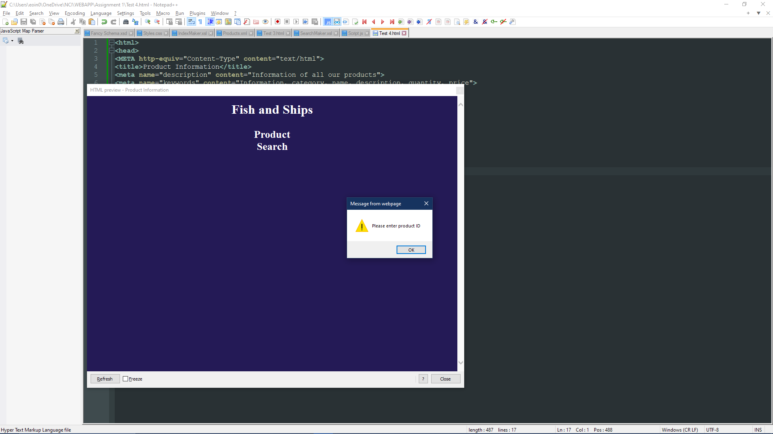

## Sixth Test

I now have a search bar in place, it lacks full functionality but is taking text input. I need to alter the placeholder and add a search button or image of something search related.

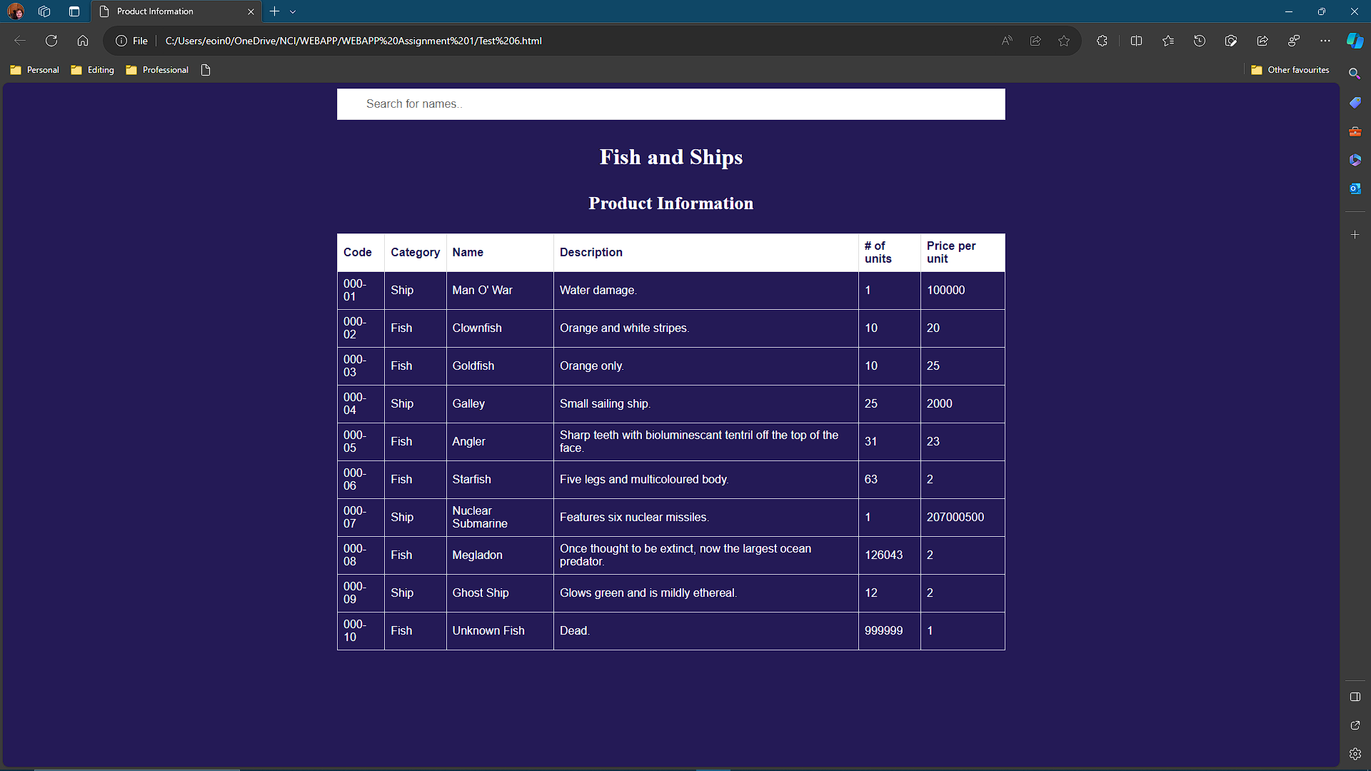

## Seventh Test

The search function is now fully operational, all that is left is to beautify the website and verify I have satisfied the brief.

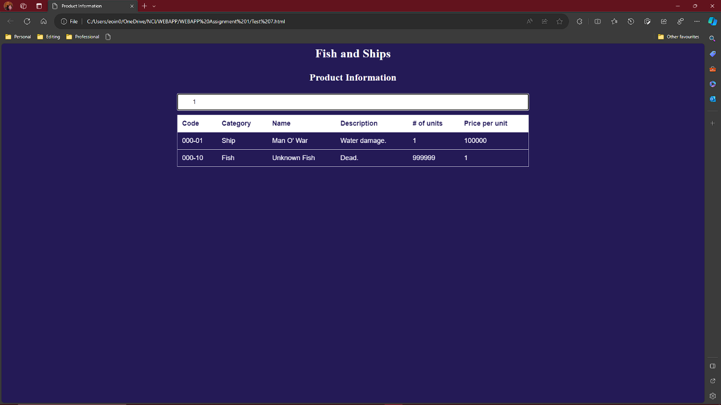

Eighth Test

I now have a message in place to show that there are no matches when it is the case. I also have a navigation bar but its lacking functionality. I also made it look prettier, I am using the google fonts lobster and red hat display.

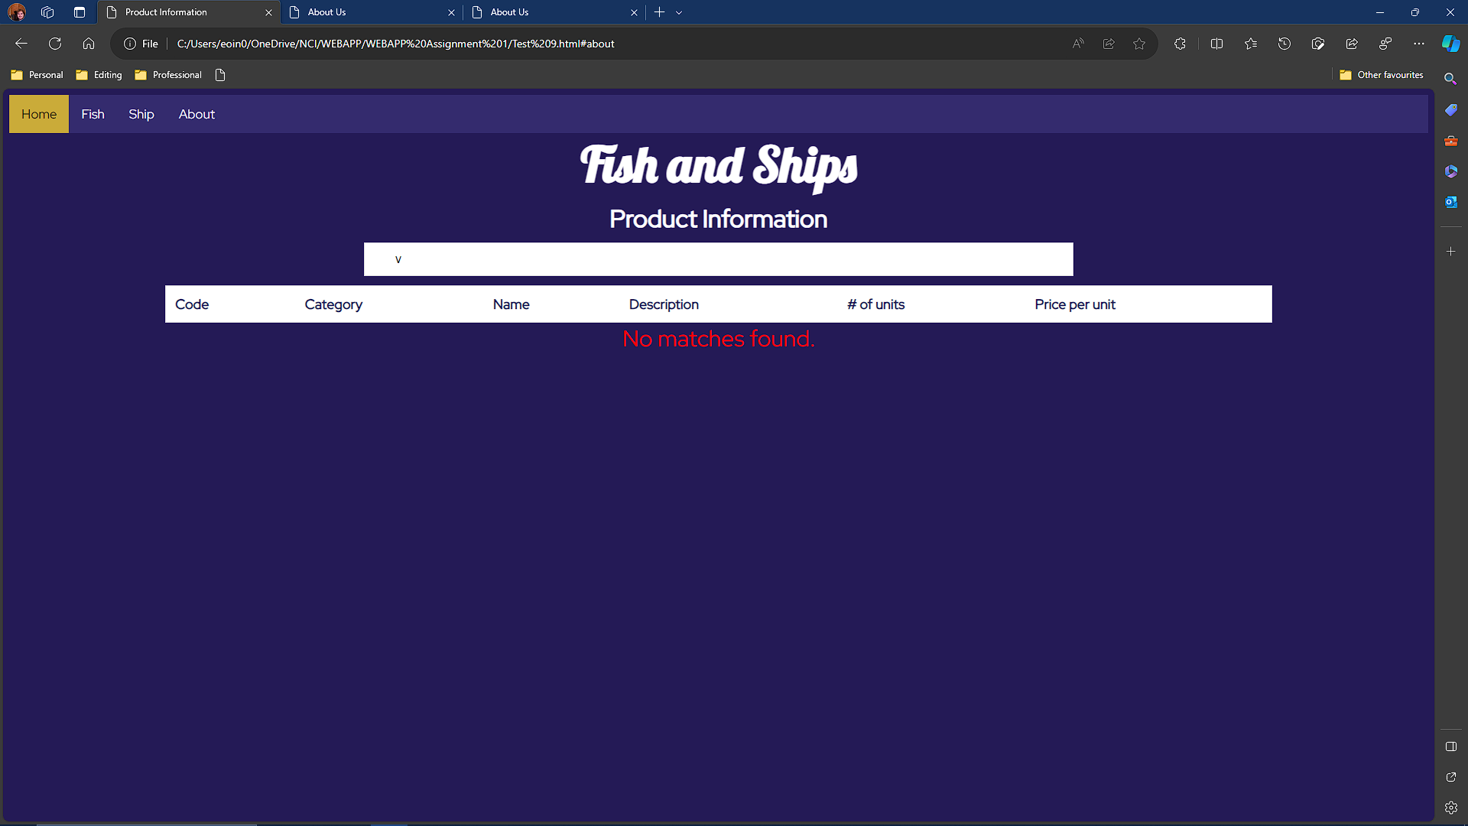

# Issues

When transforming the file, the closing tags in the head of the html were not being ported over, it was very strange but also didn’t stop anything from working which was even stranger. It is likely that this is due to the extension in notepad++ just not being coded correctly.

When including the JavaScript in the xslt file, it was being recognised as its own code and telling me whitespace wasn’t allowed. I now know that I need to add <![CDATA[]]> for it to not be ruined.

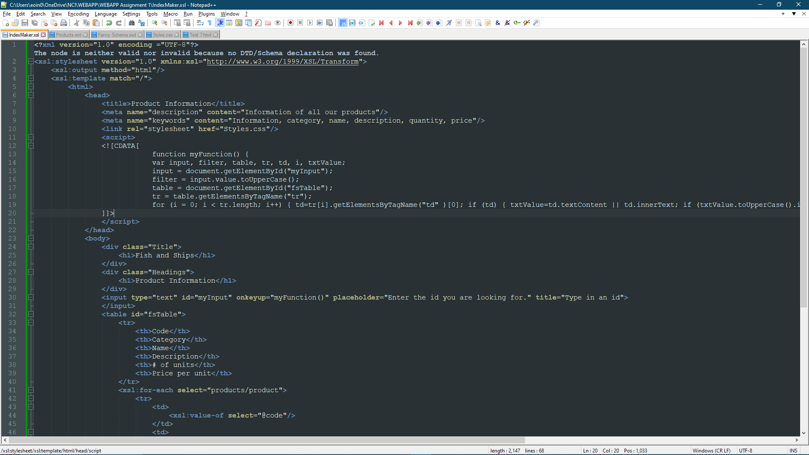

I didn’t know the difference between fish and ships so I looked it up and wow you would not believe these things.